Build
MTA.yaml - Right Click and select Build MTA Proejct
Command - --build-target CF --mtar ./mta_archives/agel-mmts-web_0.0.1.mtar build

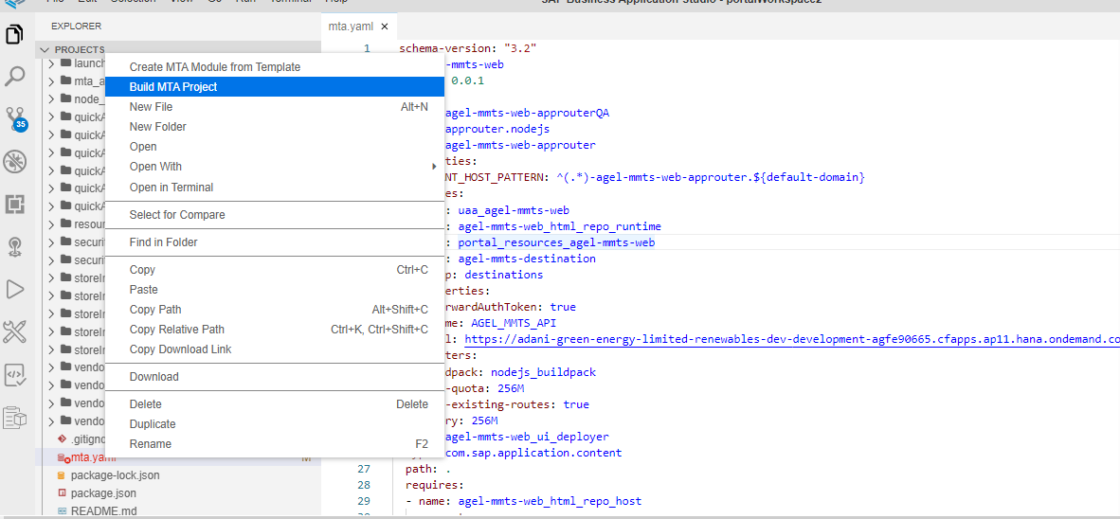

MTAR – Generated
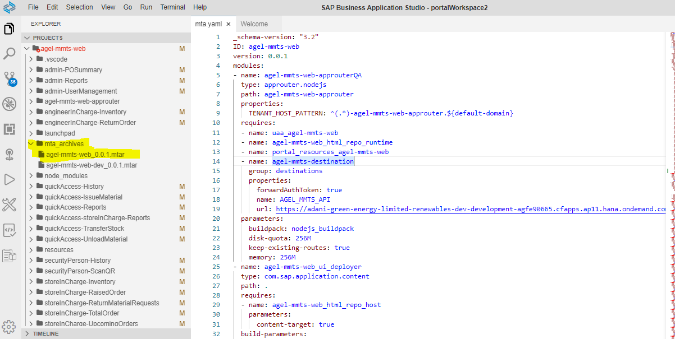

Deploy – MTAR

Command - $ cf deploy mta_archives/agel-mmts-web_0.0.1.mtar

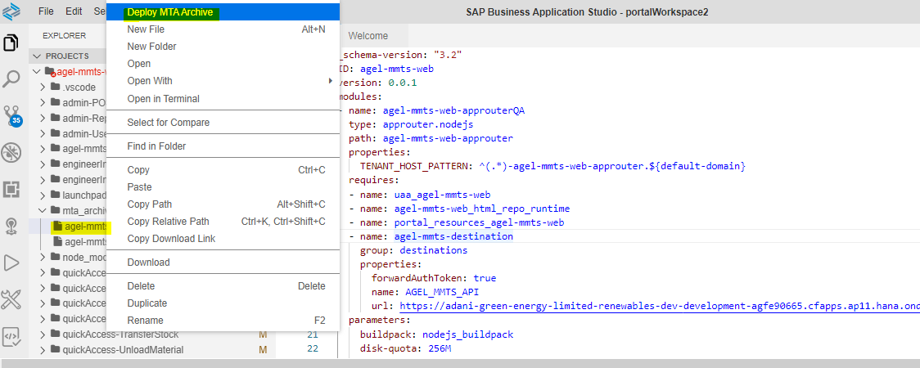

Launchpad – View – Successfully Deployed

